How to Open a .CSV File and Insert a Scatter Chart in Google Sheets and Microsoft Excel

Google Sheet Users:

Open a. csv file in Google Sheets
- First, you must enable “Convert Uploads” in Google Drive settings. To do so, go to drive.google.com/drive/settings and log in to your account. Next, in the pop-up window, check the box next to “Convert uploaded files to Google Docs editor format,” and then click Done.
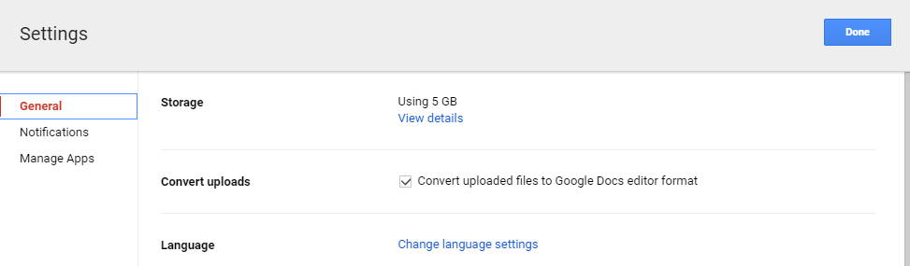
- To open a .csv file, simply open Google Drive and drag-and-drop a .csv file to the page.

Insert a Scatter Chart in Google Sheets
To map out the statistics in Google Sheets, select Insert > Chart… and choose Scatter under the Chart Types tab in Chart Editor.
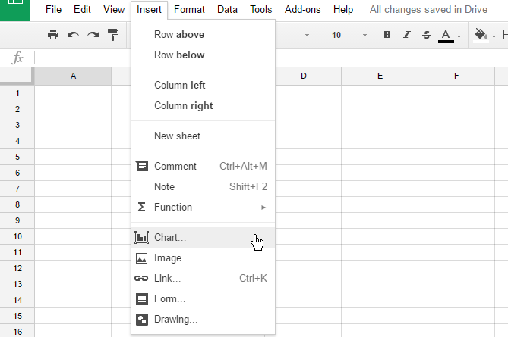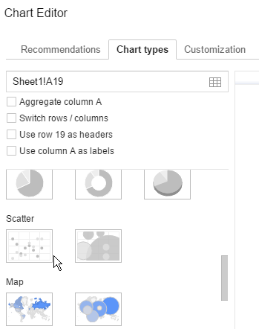

Microsoft Excel Users:

Open a. csv file in Microsoft Excel
To open a .csv file in Microsoft Excel is easy. Simply open Microsoft Excel and drag-and-drop a .csv file to the page.

Insert a Scatter Chart in Microsoft Excel
To map out the statistics in Microsoft Excel, select Insert > Chart and choose Scatter.
